|  |
| --- |
| 1. Which of these packages contains all the classes and methods required for event handling in Java? |

1. Java.applet
2. Java.awr
3. Java.event
4. Java.awt.event
5. Complete the code –

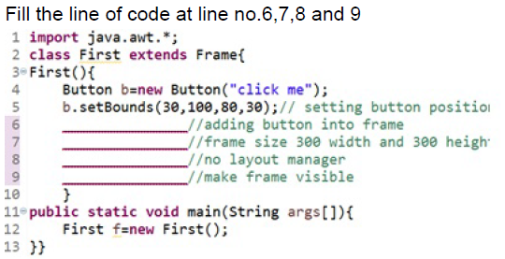

1. 6: add(b); 7: setSize (300,300); 8: setLayout(FlowLayout); 9: setVisible(true);
2. 6: add(b); 7: setSize (300,300); 8: setLayout (null); 9: setVisible(true);
3. 6:add(button); 7: setSize (300,300); 8: setLayout (null); 9: setVisible(true);
4. 6:add(b); 7: setSize (300,300); 8:setLayout (null); 9: setVisible ();
5. Which of the following displays components row-by-row in the order in which they were added to the JFrame?
6. CardLayout
7. FlowLayout
8. BorderLayout
9. GridLayout
10. If programmer wants to copy content from File1.txt to File2.txt using Character Stream Class, then which of the following is correct?
11. FileInputStream("File1.txt") and FileOutputStream("File2.txt");
12. FileReader("File1.txt") and FileWriter("File2.txt");
13. FileReader("File2.txt") and FileWriter("File1.txt");
14. FileInputStream("File2.txt") and FileOutputStream("File1.txt");

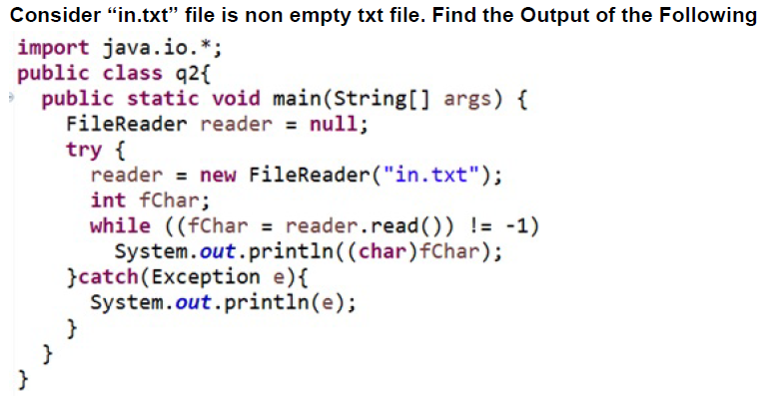

1. Read and Print Content from File ”in.txt” in Single line
2. Error at while ((fChar = reader.read()) != -1)
3. Error at line System.*out*.println((char)fChar);
4. Read and Print Content from File ”in.txt” in separate line
5. Write the Java program for write a data in abc.txt file.
6. Write the Java program for read a data from abc.txt file and display on screen.
7. Write a program for create a frame and add two labels, two text fields for Student_ID and Student_Name and one button for Submit.
8. Write a Java program for file handling operations – create a new file, check that file is readable /writable or not ,find the length of a file and ,display the name of file, display absolute path of a file and delete the data from file.

**Note: For theory questions write small code wherever it required.**

1. Differences between AWT and Swing.
2. Explain File Handling concept.
3. Write about layout manager in Java GUI.
4. Write about event handling in java GUI.
5. What are the different classes are available for read and write operation for File .Explain in short.